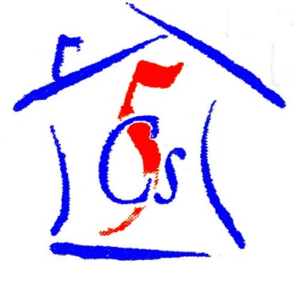

***C****hernobyl* ***C****hildren* ***C****ancer* ***C****are* ***C****ardiff*

53 Heol Llanishen Fach Rhiwbina Cardiff CF14 6LB

Tel: +44 (0)29 20624730

www.five-cs.org info@five-cs.org

Registered Charity Number: 1077451

**Eighteen months has now passed since we took over The 5Cs- and what a year and a half it has been! It has seen the origins of what will now become our annual Cocktail Party fundraiser - which is not only raising vital funds towards our donation to the Belarusian Childrens Hospice, but is proving to be a popular night out for all attending! This year has also seen some of our members stepping up to trustee and team leader positions.**

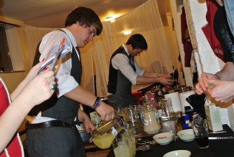

**The November 1920’s Cocktail Party raised us over £900. The event was not only an outstanding success but was a great social evening. The bartenders were absolute stars with their non-stop drink making and the night would not have run so smoothly if not for their hard work. Thank you to everyone who attended and helped!**

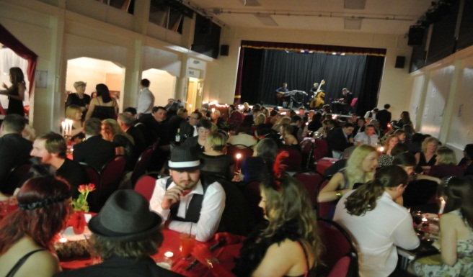

**The second fundraiser of the year was the ‘The World VarieTea’, with a selection of international tea and cakes for sale from around the world, with costumes and decorations galore! This event raised us over £400- Thank You to our army of cake makers!**

**We have also had other small fundraisers including a bucket collection and publicity weekend at Sainsbury’s, Thornhill- Thanks to our members and to Lawrence at Sainsbury’s for your continuing support!**

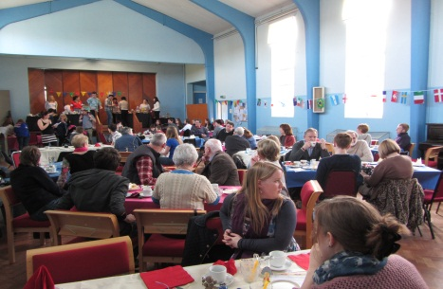

**The Summer volunteering project is well underway…there will be a total of 30 volunteers going to Zabrodya in the summer. These are a combination of new volunteers and existing members originating from Whitchurch High School and Howells School of Llandaff. We hope that we will all have another successful year! We have just returned from Minsk where we were able to deliver the donation of over $5000 to the Hospice and the necessary materials for our Summer project to the camp.**

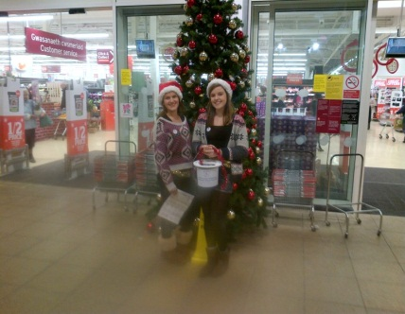

**A special thank you must go to those who have run sponsored events and fundraisers on our behalf, we are always amazed by everyone’s generosity!**

**The Interactors at Whitchurch High School and Howells School of Llandaff have, as usual, been a source of constant support and funds and we are forever grateful! Also to the Rotary Club of Cardiff Breakfast for your fantastic support of not only The 5Cs but us personally.**

**A final thank you goes to all of our members who help us all year round. The fundraisers and the running of the charity as a whole would not be possible with out all your hard work. Thank you as always- and here’s to another Successful summer!**

**Please see our website at www.five-cs.org, our Facebook page (search Chernobyl Children Cancer Care Cardiff) or our Twitter account (@FiveCsCardiff) for more detailed and up to date information, photos and contact information.**

***Zac and Beth***